Biobank and Biospecimen Management System
(CBIO204) Fundamental of database

Name: Basmala Raafat
Id: 221001922

Supervised by :
Dr. Mohamed elsayahh

Problem Statement:
Biobanks play a crucial role in biomedical research by collecting, cataloging, and distributing biological specimens (e.g., blood, tissue, DNA). Traditional manual record keeping or basic spreadsheet tracking leads to data redundancy, lost specimens, lack of storage traceability, legal non compliance regarding donor consent, and poor tracking of sample consumption by researchers. A centralized relational database system is required to maintain complete data integrity, enforce legal consent verification, track physical freezer locations, and manage researcher test requests safely.
Project Scope
The scope of the Biobank and Biospecimen Management System includes:
- Donor & Consent Tracking: Managing donor profiles and ensuring informed consent records are explicitly tied to donors.
- Sample Inventory Management: Cataloging biospecimens by type, volume, collection date, and precise physical storage location.
- Freezer Location Tracking: Mapping exact freezers, shelves, and boxes to prevent sample loss.
- Research & Usage Workflow: Registering research personnel, processing test requests, and auditing exact sample volumes consumed in experiments.
System Assumptions
- Every biological sample in the biobank belongs to exactly one registered donor.
- A donor can sign multiple consent forms over time (e.g., general vs. specific research consents).
- Freezers are divided into distinct shelves and boxes, each identified by structured location IDs.
- Test requests submitted by researchers can involve multiple samples, and a single sample can be utilized across multiple test requests over time.

Major Business Rules
- Consent Requirement: A donor must sign at least one consent form to be registered in the biobank system.
- Sample Integrity: A sample cannot exist without an associated donor, sample type, and physical storage location.
- Volume Safety Constraint: The volume of a sample used in a test request must not exceed the remaining available volume in the freezer.
- Controlled Request Lifecycle: Test requests must follow structured status states (Pending, Approved, Rejected, Completed).
3. List of Entities, Attributes, and Key Decisions
The database consists of 8 normalized entities:
Entity Name | Primary Key (PK) | Foreign Keys (FK) | Attributes
Donor | Donor_ID | None | First Name, Last Name, Date of Birth, Contact Number
Consent | Consent_ID | Donor_ID | Consent_Date, Consent_Type
Sample Type | Type_ID | None | Type_Name (Unique), Handling Instructions
Storage Location | Location_ID | None | Freezer_Number, Shelf_Number, Box_Number
Sample | Sample_ID | Donor_ID, Type_ID, Location_ID | Collection Date, Volume
Researcher | Researcher_ID | None | First Name, Last Name, Institution Name, Email (Unique)
Test Request | Request_ID | Researcher_ID | Request_Date, Status
Sample_Usage | (Sample_ID, Request_ID) | Sample_ID, Request_ID | Quantity Used ml, Usage Date

- Decoupling Consent from Donor: Separating consent records from the Donor table allows donors to sign updated consents over time without violating Third Normal Form (3NF).
- Associative Entity (Sample Usage): Created to resolve the Many-to-Many ($M:N$) relationship between Sample and Test_Request, capturing transaction-specific volume consumption.
- Storage Abstraction: Storing physical location details in a separate Storage Location table prevents repeating freezer metadata across thousands of samples.

4. ER Diagram, Cardinality Ratios, and Participation Constraints

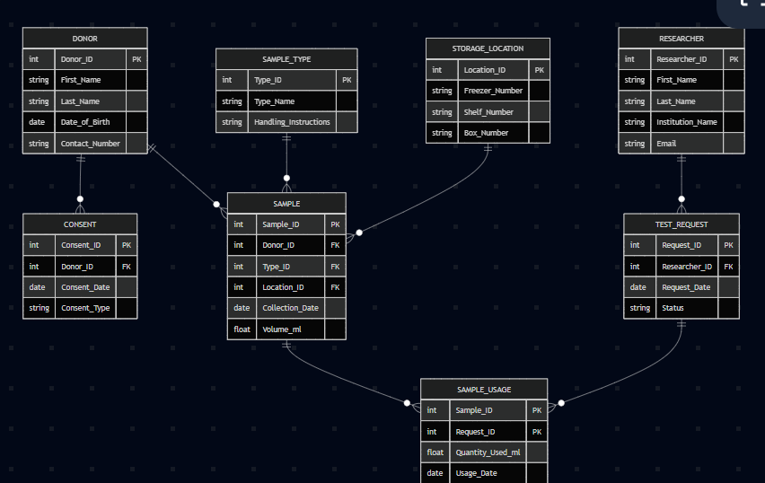

Relationship Specifications
- Donor and Consent (Signs)
    - Cardinality: $1:N$ (One donor can sign multiple consents).
    - Participation: Mandatory for both (A consent must belong to a donor, and a donor must sign a consent to be registered).

- Donor and Sample (Provides)
    - Cardinality: $1:N$ (One donor provides multiple samples).
    - Participation: Mandatory for Sample, Optional for Donor (A registered donor might not have provided a sample yet, but every sample must have a donor).

- Sample Type and Sample (Categorizes)
    - Cardinality: $1:N$ (One sample type categorizes multiple samples).
    - Participation: Mandatory for Sample, Optional for Sample Type (New sample types can be configured before samples are assigned).
- Storage Location and Sample (Stores)
    - Cardinality: $1:N$ (One location stores multiple samples).
    - Participation: Mandatory for Sample, Optional for Storage Location (A freezer box/shelf might currently be empty).
- Researcher and Test Request (Submits)
    - Cardinality: $1:N$ (One researcher submits multiple test requests).
    - Participation: Mandatory for Test Request, Optional for Researcher (A researcher can be registered prior to submitting requests).
- Sample, Test Request, and Sample Usage (Resolved $M:N$)
    - Sample to Sample Usage (Used in): $1:N$ Cardinality. One sample can have multiple usage records over time.
    - Test Request to Sample Usage (Contains): $1:N$ Cardinality. One test request can involve multiple sample usage records.
5. Relational Schema & Constraints
- Donor ($Donor_ID$, First_Name, Last_Name, Date_of_Birth, Contact_Number)
  - Primary Key: Donor_ID
- Consent ($Consent_ID$, Donor_ID, Consent Date, Consent Type)
  - Primary Key: Consent_ID
  - Foreign Key: Donor_ID references Donor (Donor_ID) ON DELETE CASCADE
- Sample Type ($Type_ID$, Type_Name, Handling_Instructions)
  - Primary Key: Type_ID
  - Unique Constraint: Type_Name
- Storage Location ($Location_ID$, Freezer_Number, Shelf_Number, Box_Number)
  - Primary Key: Location_ID
- Sample ($Sample_ID$, Donor_ID, Type_ID, Location_ID, Collection Date, Volume)
  - Primary Key: Sample_ID
  - Foreign Keys:
    - Donor_ID references Donor(Donor_ID) ON DELETE CASCADE
    - Type_ID references Sample Type(Type_ID) ON DELETE RESTRICT
    - Location_ID references Storage Location(Location_ID) ON DELETE RESTRICT
  - Check Constraint: CHECK (Volume_ml >= 0)
6.Researcher ($Researcher_ID$, First_Name, Last_Name, Institution_Name, Email)
  - Primary Key: Researcher_ID
  - Unique Constraint: Email
7.Test Request ($Request_ID$, Researcher_ID, Request Date, Status)
  - Primary Key: Request_ID
  - Foreign Key: Researcher_ID references Researcher (Researcher_ID) ON DELETE CASCADE
  - Enum Constraint: Status IN ('Pending', 'Approved', 'Rejected', 'Completed')
8.Sample_Usage ($Sample_ID,Request_ID$, Quantity_Used_ml, Usage_Date)
  - Composite Primary Key: (Sample_ID, Request_ID)
  - Foreign Keys:
    - Sample_ID references Sample(Sample_ID) ON DELETE CASCADE
    - Request_ID references Test_Request(Request_ID) ON DELETE CASCADE
  - CHECK (Quantity_Used_ml > 0)

6. Normalization Explanation (1NF to 3NF)
First Normal Form (1NF)
- All attributes contain atomic values (e.g., individual dates, single volumes).
- No repeating groups exist in any table.
- Every table has a clearly defined Primary Key.
Second Normal Form (2NF)
- Meets all 1NF criteria.
- All non-key attributes are fully functionally dependent on the primary key.
- In the associative table Sample Usage, non-key attributes (Quantity_Used_ml, Usage_Date) depend on the full composite key (Sample_ID, Request_ID) and not a subset of it.
Third Normal Form (3NF)
- Meets all 2NF criteria.
- No transitive dependencies exist (non-key attributes do not depend on other non-key attributes):
  - Consent_Type depends on Consent_ID, not on Donor_ID, eliminating transitive dependency from Donor.
  - Handling Instructions depends directly on Type_ID, preventing repeating handling parameters inside Sample.
  - Freezer Number depends on Location_ID, preventing physical location attributes from repeating inside Sample.

7. MY SQL Code
Table Creation
CREATE DATABASE IF NOT EXISTS biobank_db;
USE biobank_db;
1. Donor
CREATE TABLE Donor (
Donor_ID INT AUTO_INCREMENT PRIMARY KEY,
First_Name VARCHAR(50) NOT NULL,
Last_Name VARCHAR(50) NOT NULL,
Date_of_Birth DATE NOT NULL,
Contact_Number VARCHAR(20)
);
2. Consent
CREATE TABLE Consent (
Consent_ID INT AUTO_INCREMENT PRIMARY KEY,
Donor_ID INT NOT NULL,
Consent_Date DATE NOT NULL,
Consent_Type VARCHAR(50) NOT NULL, -- e.g., General, Specific
FOREIGN KEY (Donor_ID) REFERENCES Donor(Donor_ID) ON DELETE CASCADE
);
3. Sample_Type
CREATE TABLE Sample_Type (
Type_ID INT AUTO_INCREMENT PRIMARY KEY,
Type_Name VARCHAR(50) NOT NULL UNIQUE,
Handling_Instructions TEXT
);
4. Storage_Location
CREATE TABLE Storage_Location (
Location_ID INT AUTO_INCREMENT PRIMARY KEY,
Freezer_Number VARCHAR(20) NOT NULL,
Shelf_Number INT NOT NULL,
Box_Number INT NOT NULL
);
5. Sample
CREATE TABLE Sample (
Sample_ID INT AUTO_INCREMENT PRIMARY KEY,
Donor_ID INT NOT NULL,
Type_ID INT NOT NULL,
Location_ID INT NOT NULL,
Collection_Date DATE NOT NULL,
Volume_ml FLOAT CHECK (Volume_ml >= 0),
FOREIGN KEY (Donor_ID) REFERENCES Donor(Donor_ID) ON DELETE CASCADE,
FOREIGN KEY (Type_ID) REFERENCES Sample_Type(Type_ID) ON DELETE RESTRICT,
FOREIGN KEY (Location_ID) REFERENCES Storage_Location(Location_ID) ON DELETE RESTRICT
);
6. Researcher
CREATE TABLE Researcher (
Researcher_ID INT AUTO_INCREMENT PRIMARY KEY,
First_Name VARCHAR(50) NOT NULL,
Last_Name VARCHAR(50) NOT NULL,
Institution_Name VARCHAR(100) NOT NULL,
Email VARCHAR(100) NOT NULL UNIQUE
);
7. Test_Request
CREATE TABLE Test_Request (
Request_ID INT AUTO_INCREMENT PRIMARY KEY,
Researcher_ID INT NOT NULL,
Request_Date DATE NOT NULL,
Status ENUM('Pending', 'Approved', 'Rejected', 'Completed') DEFAULT 'Pending',
FOREIGN KEY (Researcher_ID) REFERENCES Researcher(Researcher_ID) ON DELETE CASCADE
);
8. Sample_Usage (Associative Table M:N)
CREATE TABLE Sample_Usage (
Sample_ID INT NOT NULL,
Request_ID INT NOT NULL,
Quantity_Used_ml FLOAT NOT NULL CHECK (Quantity_Used_ml > 0),
Usage_Date DATE NOT NULL,
PRIMARY KEY (Sample_ID, Request_ID),
FOREIGN KEY (Sample_ID) REFERENCES Sample(Sample_ID) ON DELETE CASCADE,
FOREIGN KEY (Request_ID) REFERENCES Test_Request(Request_ID) ON DELETE CASCADE
);
2. Test Data
USE biobank_db;
Insert Donors
INSERT INTO Donor (First_Name, Last_Name, Date_of_Birth, Contact_Number) VALUES
('Ahmed', 'Hassan', '1985-04-12', '01012345678'), ('Sara', 'Ali', '1990-08-25', '01123456789'),
('Mohamed', 'Ibrahim', '1978-11-05', '01234567890'), ('Mona', 'Zaki', '1995-02-14', '01098765432'),
('Omar', 'Farouk', '1982-09-30', '01198765432'), ('Layla', 'Mahmoud', '1988-12-01', '01298765432'),
('Khaled', 'Said', '1975-06-18', '01055556666'), ('Hana', 'Gamal', '1992-03-22', '01166667777'),
('Youssef', 'Nabil', '1980-10-10', '01277778888'), ('Nour', 'El-Din', '1998-07-07', '01088889999');
Insert Consents
INSERT INTO Consent (Donor_ID, Consent_Date, Consent_Type) VALUES
(1, '2026-01-10', 'General'), (2, '2026-01-15', 'Specific'),
(3, '2026-02-01', 'General'), (4, '2026-02-20', 'General'),
(5, '2026-03-05', 'Specific'), (6, '2026-03-12', 'General'),
(7, '2026-04-10', 'General'), (8, '2026-04-18', 'Specific'),
(9, '2026-05-02', 'General'), (10, '2026-05-22', 'General');
Insert Sample Types
INSERT INTO Sample_Type (Type_Name, Handling_Instructions) VALUES
('Whole Blood', 'Keep refrigerated at 4C'), ('Blood Plasma', 'Freeze at -80C immediately'),
('Genomic DNA', 'Store at -20C'), ('RNA Extract', 'Store at -80C, sensitive to degradation'),
('Saliva', 'Keep at room temperature before extraction'), ('Tissue Biopsy', 'Snap freeze in liquid nitrogen'),
('Urine', 'Refrigerate at 4C'), ('Serum', 'Freeze at -20C'),
('Cell Culture', 'Incubate at 37C'), ('Protein Extract', 'Store at -80C');
Insert Storage Locations
INSERT INTO Storage_Location (Freezer_Number, Shelf_Number, Box_Number) VALUES
('F-01', 1, 1), ('F-01', 1, 2), ('F-01', 2, 1), ('F-02', 1, 1), ('F-02', 1, 2),
('F-03', 1, 1), ('F-03', 2, 1), ('F-04', 1, 1), ('F-04', 2, 2), ('F-05', 1, 1);
Insert Samples
INSERT INTO Sample (Donor_ID, Type_ID, Location_ID, Collection_Date, Volume_ml) VALUES
(1, 1, 1, '2026-01-12', 10.5), (2, 2, 2, '2026-01-16', 5.0),
(3, 3, 3, '2026-02-02', 2.0), (4, 4, 4, '2026-02-21', 1.5),
(5, 5, 5, '2026-03-06', 8.0), (6, 6, 6, '2026-03-13', 0.5),
(7, 7, 7, '2026-04-11', 15.0), (8, 8, 8, '2026-04-19', 4.0),
(9, 9, 9, '2026-05-03', 10.0), (10, 10, 10, '2026-05-23', 3.0);
Insert Researchers
INSERT INTO Researcher (First_Name, Last_Name, Institution_Name, Email) VALUES
('Tarek', 'Fahmy', 'Nile University', 'tfahmy@nu.edu.eg'), ('Dina', 'Samy', 'Nile University', 'dsamy@nu.edu.eg'),
('Magdy', 'Tolba', 'Cairo University', 'mtolba@cu.edu.eg'), ('Rania', 'Kamal', 'Ain Shams University', 'rkamal@asu.edu.eg'),
('Wael', 'Ghonim', 'Nile University', 'wghonim@nu.edu.eg'), ('Salma', 'Adel', 'Alexandria University', 'sadel@alexu.edu.eg'),
('Hisham', 'Zaki', 'Nile University', 'hzaki@nu.edu.eg'), ('Noha', 'Fouad', 'Cairo University', 'nfouad@cu.edu.eg'),
('Kareem', 'Safwat', 'Nile University', 'ksafwat@nu.edu.eg'), ('Eman', 'Tawfik', 'Ain Shams University', 'etawfik@asu.edu.eg');
Insert Test Requests
INSERT INTO Test_Request (Researcher_ID, Request_Date, Status) VALUES
(1, '2026-06-01', 'Approved'), (2, '2026-06-05', 'Pending'),
(3, '2026-06-10', 'Completed'), (4, '2026-06-12', 'Rejected'),
(5, '2026-06-15', 'Approved'), (6, '2026-06-18', 'Pending'),
(7, '2026-06-20', 'Completed'), (8, '2026-06-22', 'Approved'),
(9, '2026-06-25', 'Pending'), (10, '2026-06-28', 'Approved');
Insert Sample Usage
INSERT INTO Sample_Usage (Sample_ID, Request_ID, Quantity_Used_ml, Usage_Date) VALUES
(1, 1, 2.0, '2026-06-02'), (2, 3, 1.5, '2026-06-11'),
(3, 5, 0.5, '2026-06-16'), (4, 7, 1.0, '2026-06-21'),
(5, 8, 3.0, '2026-06-23'), (6, 10, 0.2, '2026-06-29'),
(7, 1, 5.0, '2026-06-03'), (8, 3, 2.0, '2026-06-12'),
(9, 5, 4.0, '2026-06-17'), (10, 7, 1.0, '2026-06-22');
3. Required Queries
USE biobank_db;
1. Retrieval & JOIN: View Samples with Donor Names and Locations
SELECT
s.Sample_ID,
CONCAT(d.First_Name, ' ', d.Last_Name) AS Donor_Name,
st.Type_Name,
s.Volume_ml,
CONCAT('Freezer ', sl.Freezer_Number, ', Shelf ', sl.Shelf_Number) AS Location
FROM Sample s
JOIN Donor d ON s.Donor_ID = d.Donor_ID
JOIN Sample_Type st ON s.Type_ID = st.Type_ID
JOIN Storage_Location sl ON s.Location_ID = sl.Location_ID;
2. Aggregation: Find the total volume of samples per Sample Type
SELECT
st.Type_Name,
COUNT(s.Sample_ID) AS Total_Samples,
SUM(s.Volume_ml) AS Total_Volume_ml
FROM Samples
JOIN Sample_Type st ON s.Type_ID = st.Type_ID
GROUP BY st.Type_Name;
3. Subquery: Find Researchers who have made 'Approved' or 'Completed' test requests
SELECT First_Name, Last_Name, Institution_Name
FROM Researcher
WHERE Researcher_ID IN (
SELECT Researcher_ID
FROM Test_Request
WHERE Status IN ('Approved', 'Completed')
);
4. Update Operation: Update a request status from Pending to Approved
UPDATE Test_Request
SET Status = 'Approved'
WHERE Request_ID = 2;
5. Delete Operation: Remove a rejected test request
DELETE FROM Test_Request
WHERE Status = 'Rejected' AND Request_ID = 4;
4. Required Views
USE biobank_db;
Complete Donor Profile with Consent Status
CREATE VIEW view_donor_profiles AS
SELECT
d.Donor_ID,
CONCAT(d.First_Name, ' ', d.Last_Name) AS Full_Name,
d.Contact_Number,
c.Consent_Type,
c.Consent_Date
FROM Donor d
JOIN Consent c ON d.Donor_ID = c.Donor_ID;

-- View 2: Detailed Sample Inventory
CREATE VIEW view_sample_inventory AS
SELECT
s.Sample_ID,
st.Type_Name,
s.Volume_ml,
s.Collection_Date,
sl.Freezer_Number,
sl.Box_Number
FROM Sample s
JOIN Sample_Type st ON s.Type_ID = st.Type_ID
JOIN Storage_Location sl ON s.Location_ID = sl.Location_ID
WHERE s.Volume_ml > 0;
8.Results
Execution Summary Log
The Action Output log verifies that table creation, data insertion, queries, views, and triggers executed with green checkmarks across all 30 statements.
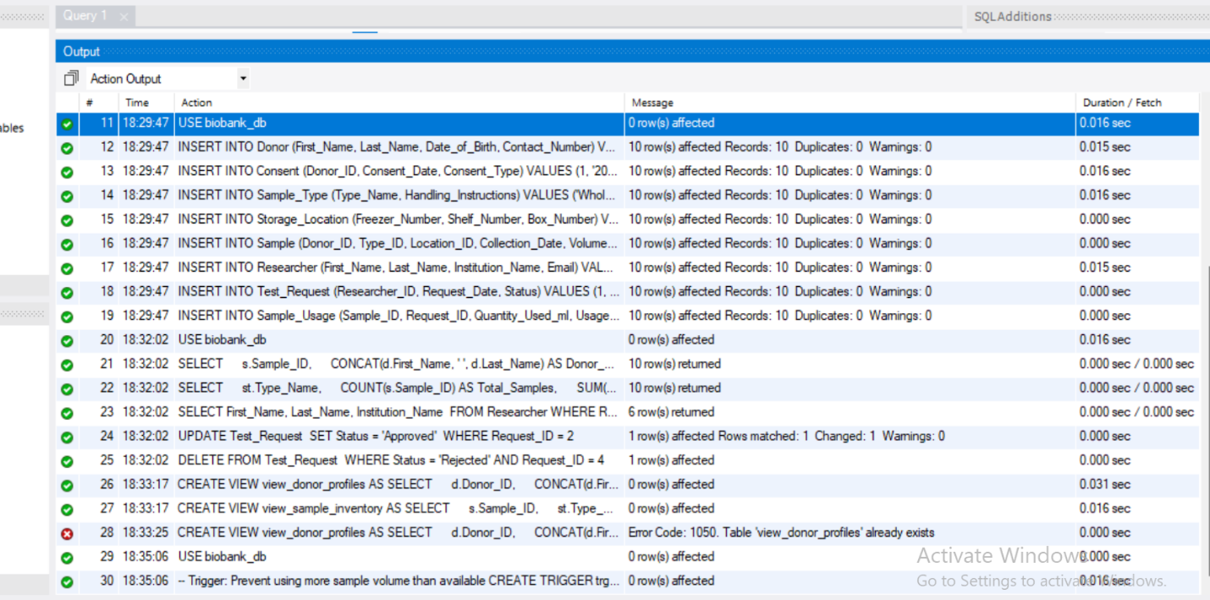
Figure1: Full MySQL Execution Log confirming zero errors.

Result Grids
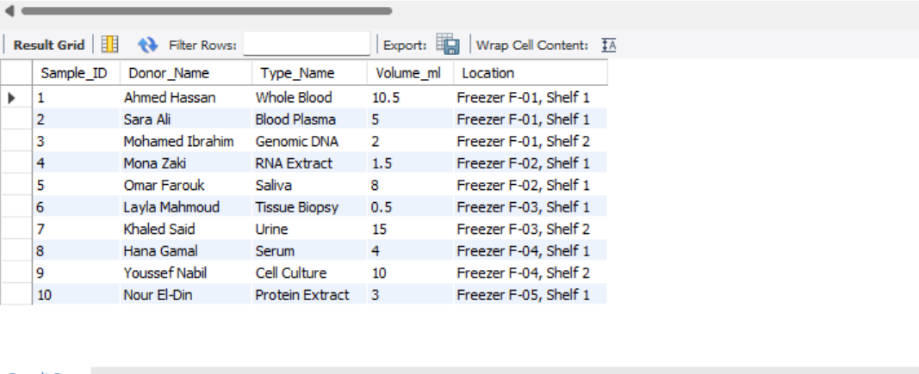
Figure2:sample table
Data Grid (SELECT * FROM Sample;)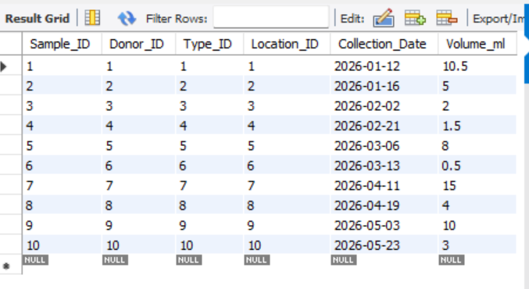
Figure 3: Populated Sample table output showing 10 sample records.

3.Aggregation Query Result Grid
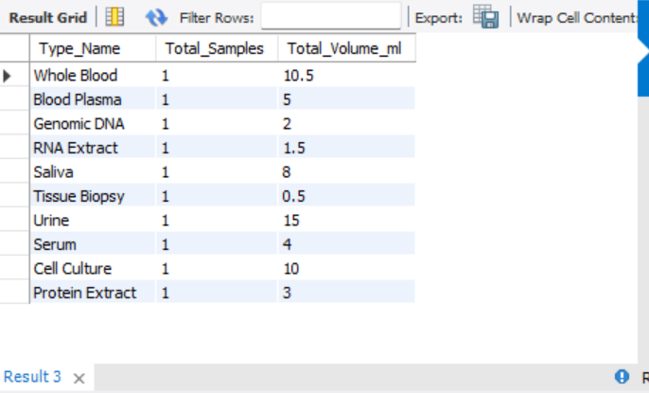
Figure4: Aggregated sample volume counts grouped by Sample Type Name.
4.Database View Result Grid
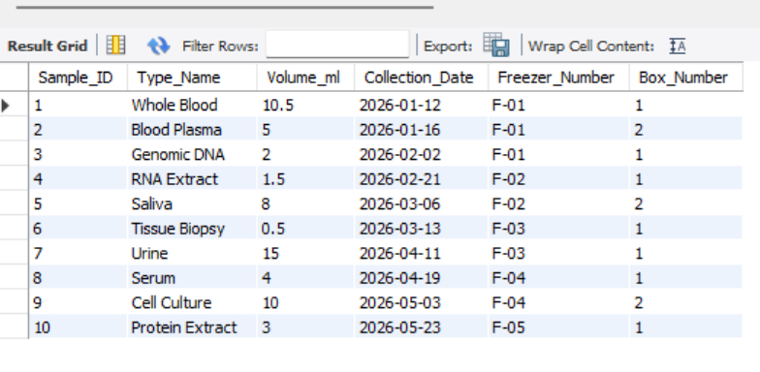
Figure4: Virtual inventory view displaying active sample volumes and freezer locations
9. Explanation
Multi-Table Master Inventory Query
- Purpose & Logic Explanation:
Retrieves a complete overview of all stored biospecimens alongside donor identity, sample classification, and precise freezer locations.
  - The query performs three explicit INNER JOIN operations connecting Sample to Donor, Sample_Type, and Storage_Location using their primary/foreign key relationships (Donor_ID, Type_ID, Location_ID).
  - Uses CONCAT(d.First_Name, ' ', d.Last_Name) to combine donor names into a single readable field.
  - Uses CONCAT() to format freezer and shelf numbers into an actionable location string (e.g., "Freezer 1, Shelf 2") for laboratory staff.
2. Aggregated Volume and Count per Specimen Type
- Purpose & Logic Explanation:
Provides biobank managers with high-level metrics regarding total inventory volume and specimen counts per biological category (e.g., Plasma, DNA, Whole Blood).
  - Uses GROUP BY st.Type_Name to categorize records by sample type name.
  - Employs the aggregate function COUNT(s.Sample_ID) to tally total physical samples per type.
  - Employs SUM(s.Volume_ml) to calculate total fluid volume remaining across all specimens of each category
1. Donor Profile & Consent Verification View (view_donor_profiles)
- Purpose & Logic Explanation:
Simplifies regulatory compliance audits by combining donor identity with their signed legal consent forms.
  - Integrates Donor and Consent tables using a JOIN on Donor_ID.
  - Allows compliance officers to check consent dates and types quickly without writing raw join queries or requiring direct write-access to core donor tables.
2. Active Sample Inventory View (view_sample_inventory)
- Purpose & Logic Explanation:
Serves as a real-time virtual inventory table for laboratory technicians preparing experiments.
  - Abstracts underlying joins between Sample, Sample_Type, and Storage_Location.
  - Applies a filtering condition WHERE s.Volume_ml > 0 to automatically exclude completely depleted or exhausted samples from daily search results.
Database Triggers & Automated Safety Rules
Sample Volume Protection Trigger (trg_check_sample_volume)
- Purpose & Logic Explanation:
Enforces a strict business constraint preventing researchers from logging test requests that request more volume than physically exists in a freezer box.
  - Configured as a BEFORE INSERT trigger on the Sample_Usage associative table.
  - Reads the current available volume from Sample.Volume_ml for the target Sample_ID into a temporary variable (available_volume).
  - Compares NEW.Quantity_Used_ml against available_volume. If the requested amount is greater, it executes SIGNAL SQLSTATE '45000', throwing a custom user error and canceling the transaction before invalid data is written.

10.Test Cases
To verify that the Biobank and Biospecimen Management System satisfies all business requirements, data integrity rules, and physical constraints, structured test cases were executed directly within MySQL Workbench. The first verification phase focused on database schema creation through the execution of the create tables.sql script, which successfully established all eight normalized tables complete with primary keys, foreign keys, and check constraints with zero execution errors.
Multitable data retrieval was subsequently validated by running a four table JOIN query across the Sample, Donor, Sample Type, and Storage Location tables. This query correctly returned a complete ten-row dataset linking specimens to full donor names and precise freezer location strings, Operational virtual views were verified by querying view sample inventory, which successfully displayed active specimens while filtering out exhausted samples with zero remaining volume, Finally, the volume safety trigger was tested by attempting to insert a sample usage request that exceeded available physical stock. The transaction was correctly blocked by the MySQL engine, raising custom error code 45000 with the expected message stating that requested quantities exceeded available sample volume, confirming robust automated data safety.

Test Case ID | Description | Input / Action | Expected Result | Actual Result | Status
TC-01 | Database & Schema Creation | Run create_tables.sql | 8 tables created with constraints | All 8 tables created successfully | PASS
TC-02 | Multi-Table Data Retrieval | Execute Query 1 JOIN | Display sample details alongside donor names and freezer numbers | 10 matching joined rows displayed | PASS
TC-03 | View Execution | SELECT * FROM view_sample_inventory; | Display filtered inventory records where volume > 0 | Correct virtual grid output generated | PASS
TC-04 | Trigger Safety Enforcement | INSERT INTO Sample_Usage with Quantity_Used_ml = 50.0 (available = 10.5) | Transaction rejected with custom error message | Red error ($×$): "Error: Requested quantity exceeds available sample volume." | PASS

11. Limitations
While the current implementation fulfills all core biobank management functions, full real-world clinical deployment presents minor areas for future refinement. Currently, the database tracks static physical storage locations but lacks automated real time temperature telemetry monitoring, which could be expanded in future iterations by integrating sensor tracking to alert staff of thermal fluctuations. Additionally, incorporating automated donor anonymization replacing direct personal names with encrypted barcode identifiers would further optimize data privacy during researcher queries.
Conclusion
In conclusion, the Biobank and Biospecimen Management System successfully provides a structured, scalable, and secure database solution designed specifically for biological sample administration. By achieving Third Normal Form across all eight entities, the system eliminates data redundancy while maintaining absolute consistency across donor profiles, consent forms, and physical storage records. Regulatory compliance is inherently built into the workflow by establishing explicit linkages between donors and signed legal consent forms prior to specimen collection.
Furthermore, the integration of automated volume safety triggers prevents the physical over-allocation of precious samples, while specialized virtual views streamline daily laboratory operations without exposing the underlying schema architecture. Fully verified through execution logs and result grids in MySQL.this database stands ready as a foundational core for integration with larger clinical Laboratory Information Management Systems.

